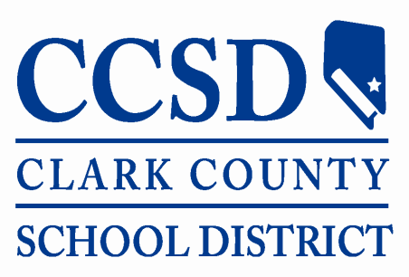
ASSESSMENT, ACCOUNTABILITY, RESEARCH,
AND SCHOOL IMPROVEMENT DIVISION

DATE:

TO: Data Services Department

FROM:

SUBJECT: ACT with Writing Exempt

Per the Nevada Department of Education Participation on Assessments Defined. “Students enrolled in Grade 11 during the administration of the College and Career Readiness Assessment (The ACT) must "participate" in order to be eligible for a standard diploma. Students enrolled in a Nevada school after the Grade 11 ACT administration are exempted; NRS 389.807: http://www.leg.state.nv.us/NRS/NRS-389.html#NRS389Sec807”.

Note: If there are no other justifications for students to be considered exempt from the ACT plus Writing Assessment. Email completed form to: AARSI.ACTAssistance@nv.ccsd.net

School Name: ___________________________________________

Student Name: __________________________________________

Local Student ID: _________________________________________

Student DOB: ____________________________________________

Date of enrollment: ______________________________________

If there are any questions, please contact the Data Services Department at (702) 799-1041, option 1.

